City of Alamo Heights
Extended Work Hours – Alamo Heights High School — Tuesday, April 21st
Scope of Work
Tuesday, April 21st – Joeris will be pouring concrete on site for the foundation of a portion of the Athletics Complex construction at Alamo Heights High School. In order to complete the pour within the workday, pump trucks will begin setting up at 4:30am.

*There is no street closure associated with this work.
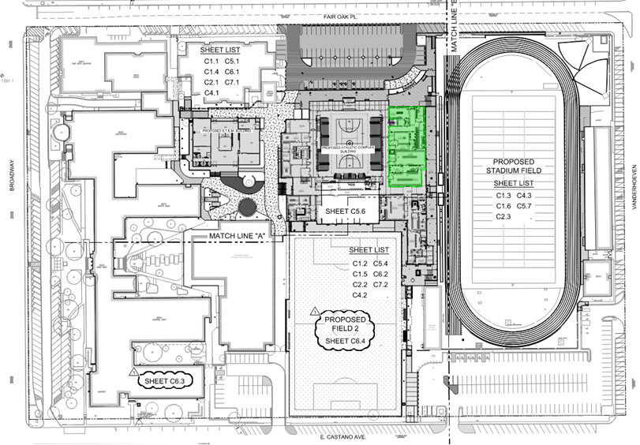
Map of Construction Areas

Outreach and Construction Contacts:

City of Alamo Heights
Nina Shealey
Director of Community Development
210-832-2250
nshealey@alamoheightstx.gov

